Name: ______________________ _____________Date: _________________________

Use with Webquest Section “Beginning the Adventure”
Fill in the blanks below with the correct words or answer the questions.
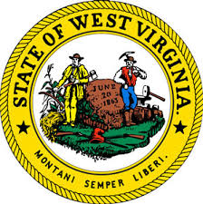

1. What things are found on the state seal? ________________________________________
2. What year is on our state seal? _________________________________________________
3. What is the state motto? ______________________________________________________
4. What is the title of West Virginia’s official state song? _______________________________
5. What is the state flower? _____________________________________________________.
6. Our state tree is a Sugar ______________________________________________________.
7. Our state fish is a ____________________________________________________________.
8. Our state butterfly is the ______________________________________________________.
9. Our state animal is the ________________________________________________________.
10. Our state fruit is the golden __________________________________________________.
11. Our state bird is the ________________________________________________________.
12. Is West Virginia Hills a good choice as the state song? Why or why not? ____________________________________________________________________________________________________________________________________________________________________________________________________________________________________________________________________________________________________________________

